Ezkylle Opiniano 01/06/2026
NW – 301 6BLOCKTECH
Prelim Badge Exam
Part A: MetaMask Wallet Management
Objectives:
- Configure and secure a digital identity.
- Manage multiple accounts (HD Wallets).
- Switch between different blockchain networks.
- Analyze transaction Metamask management.
Task 1: Account Management & Security
This task focuses on organizing your identities.
- Identity Creation:
  - Create a new account (Account 1).
  - Rename it to Primary_[Lastname]Wallet.
  - Create a second account.
  - Rename it to Storage_[Lastname]Wallet.
  - Screenshot the created accounts ( 2points)
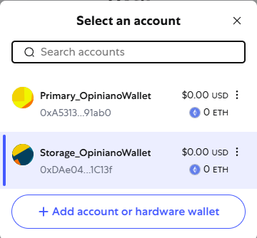
- Security Audit:
  - Locate the Private Key for Primary_[Lastname]Wallet
  - the Private Key is for one account, while the Secret Recovery Phrase is for the entire wallet.
  - Screenshot the Private key of the created accounts (2 points)
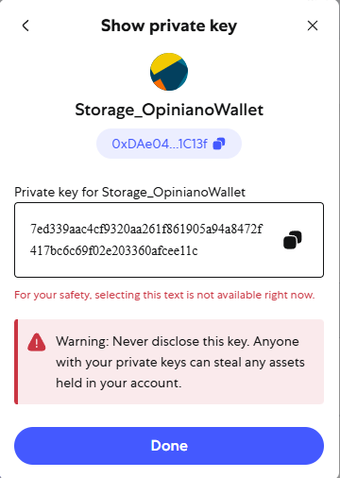
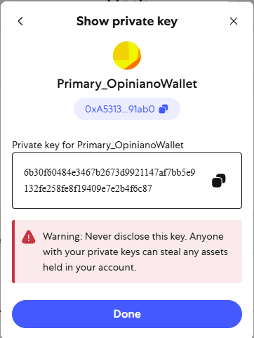

  - Account Transfer:
    - Simulate an internal transfer.
    - Copy the address of Storage_[Lastname]Wallet and use the "Send" button in Primary_[Lastname]Wallet to prepare a transaction.
    - Screenshot the newly Private key of the accounts (2 points)
Task 2: Network & RPC Configuration
This task must learn how to switch lanes of Metamask.
- Switching Networks: Toggle between Ethereum Mainnet and a Testnet (like Sepolia or Lineas).
  - If Testnets are hidden, go to Settings > Advanced > Show Test Networks.
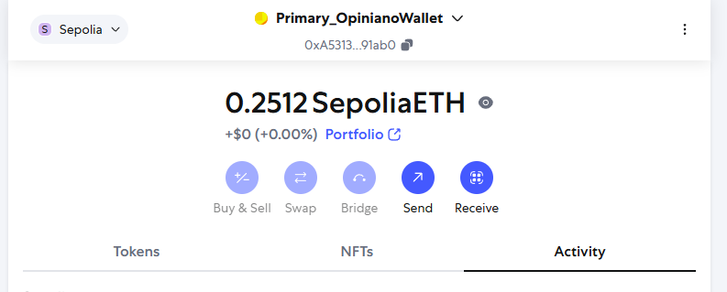
- Adding a Custom RPC: Manually add a popular Layer 2 network (like Polygon or Arbitrum) by entering the RPC URL, Chain ID, and Currency Symbol.
  - Network Name: Polygon Mainnet
  - New RPC URL: https://polygon-rpc.com/Links to an external site.
  - Chain ID: 137
  - Currency Symbol: MATIC
  - Block Explorer URL: https://polygonscan.com/ Links to an external site.
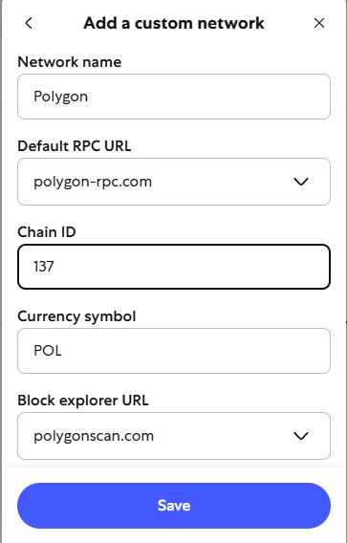
  - Screenshot the newly RPC (5 points)
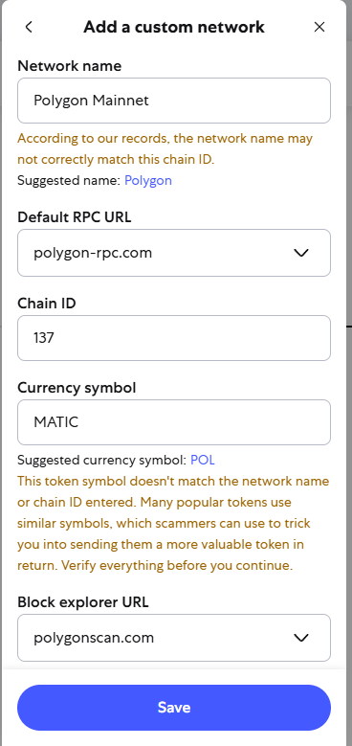

Task 3: Manual Token Import (Custom Assets)
Create a Custom Token.
- Locating a Contract Address: Go to a site like EtherscanLinks to an external site. or CoinMarketCapLinks to an external site..
- The Import Process: In MetaMask, click Tokens > Import Tokens
  - Select Custom Token
  - Create a token
    - Token Contract Address: 0xdAC17F958D2ee523a2206206994597C13D831ec7
Token Symbol: USDT
    - Token Decimal: 6
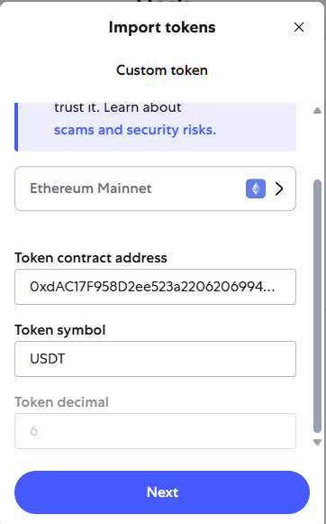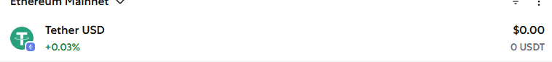

Create a Manual Entry
    - Open MetaMask and ensure you are on the Ethereum Mainnet.
    - Select Token, Click the link at the bottom that says + Import tokens
    - Switch from the Search tab to the Custom token tab.
    - Paste the address: 0xdAC17F958D2ee523a2206206994597C13D831ec7
Verification: Observe how MetaMask automatically fetches the Token Symbol and Decimal precision once the address is pasted.
  - Screenshot the newly created Token (5 points)
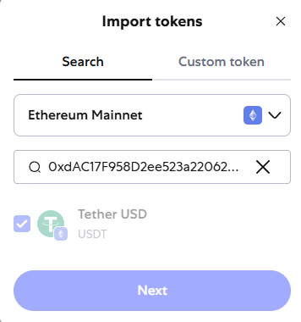

Task 4: Getting Testnet LINK
- Go to the Faucet:Visit the official Chainlink FaucetLinks to an external site..
- Connect Wallet: Click Connect Wallet and ensure MetaMask is set to the Sepolia Test Network.
- Request Tokens: Select Ethereum Sepolia from the network list.
  - Solve the CAPTCHA and send me 20 testnet LINK
- Confirm: A transaction will appear in MetaMask, and the tokens will appear in your Tokens tab within a minute.
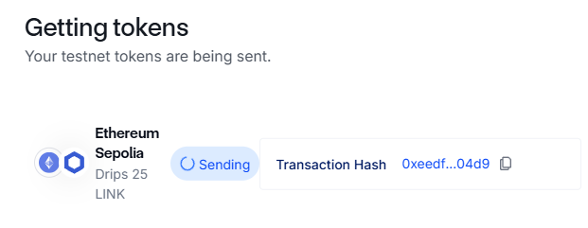
- Screenshot the balance of your Metamask (5 points)
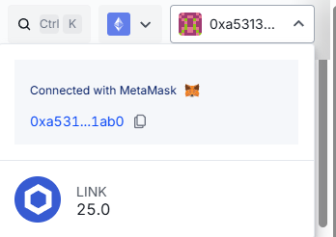

Task 5: Exporting and Analyzing State Logs
State logs are a record of every internal setting and network request your wallet has made. They are often used by developers to debug failed transactions.
- Generate the Log, go to Settings > Advanced.
  - Scroll down to Download State Logs
- Audit the File:
  - Open the downloaded .json file in a text editor.
  - Use the Find tool to search for the word identities.
  - Screenshot the generated output with the word identities (2 points)
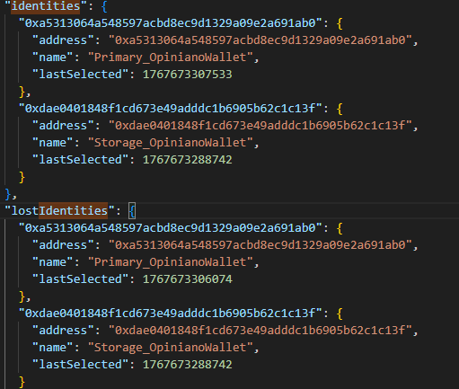

Task 6: Creating a Wallet Configuration
Note: SRP 12 words recover your funds, they do not recover your custom networks or your address book contacts.
- Backup Settings: Look for the Backup or Sync with Mobile options (or this may be labeled as Backup User Data).
- Add a new contact to your Address Book (Settings > Contacts) named LastnameTest_Account with a random wallet address.
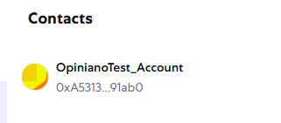
- Export your backup file.
- Find the LastnameTest_Account
- Screenshot the generated output with the word identities (2 points)
